Design Project 1: Native Mobile P2P

**Due:**  November 14, 201 by 11:59pm

**Points:**  30

**Submitting:**  a file upload

**File Types:**  pdf

**Overview**

You are asked to prototype the interaction for people to purchase goods or services from a peer-to-peer service (think craigslist) through a native mobile application. Use the requirement of it being a native app as an opportunity to take full advantage of platform capabilities such as GPS, camera, bluetooth, etc.

You will focus on several contextual scenarios which you have defined in EXERCISE WEEK 08. You have a chance to make updates for this assignment. Think beyond browsing. Think about how to arrange a safe meeting location for product hand off. Think about ways to pay after seeing the actual product. Think about returns or leaving seller feedback. Where are the gaps in the experience as it exists today? Where can you improve?

Using an assigned persona and context, you will generate an interactive prototype for a native mobile application. Pick either Android or iOS to design for. Show evidence of data-driven design. In other words, it should be apparent that the application is based on the scenarios you've created and updated from EXERCISE WEEK 08.

**Objectives**

In this assignment, you will:

1. Develop and use contextual scenarios or storyboards.
2. Document an information architecture and flow for the application.
3. Create low fidelity mockups for key interaction points.
4. Call out key mobile design patterns in use in order to justify your design decisions.
5. Learn to use Axure and build a final interactive prototype.

**Deliverables, due by Sunday, April 23 at 11:59pm:**

1. Upload a pdf document containing:

* Your persona

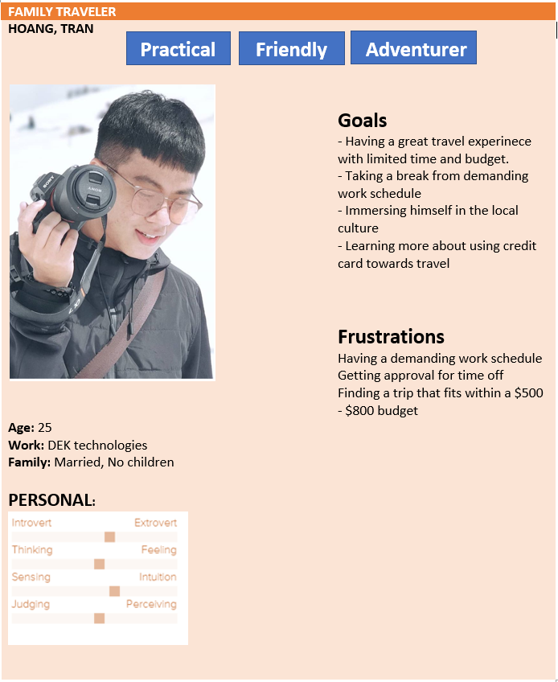

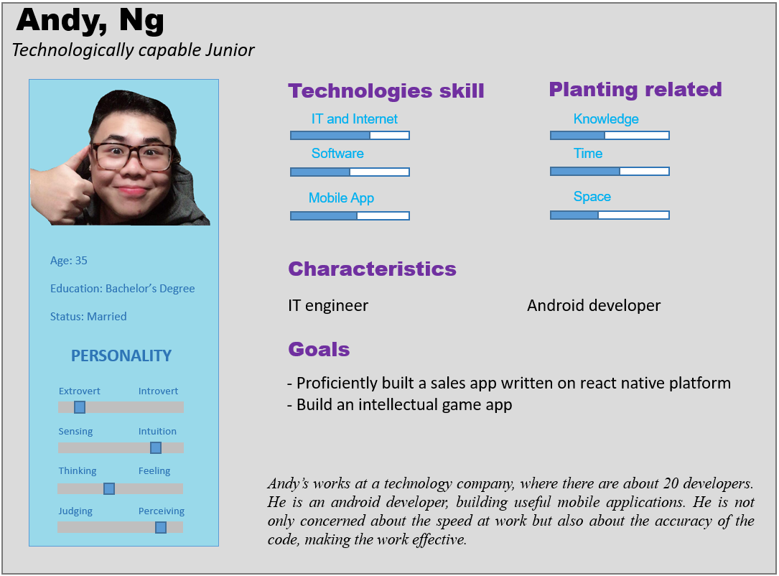

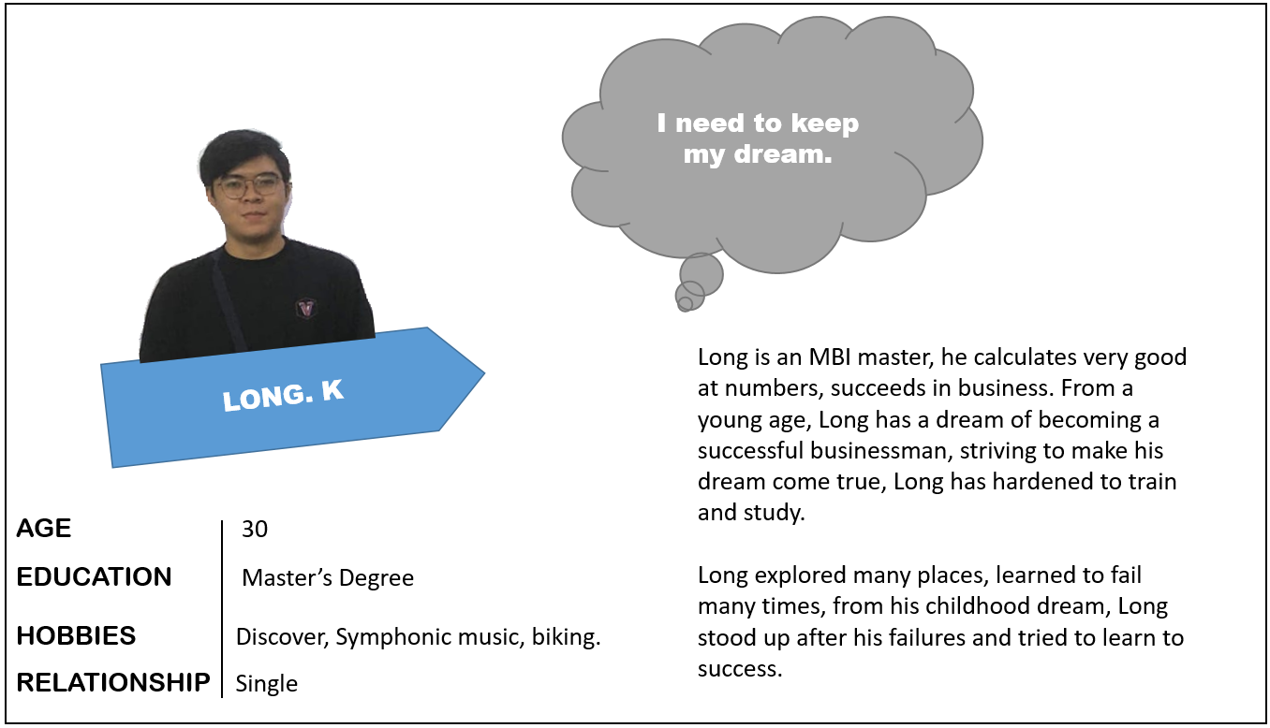

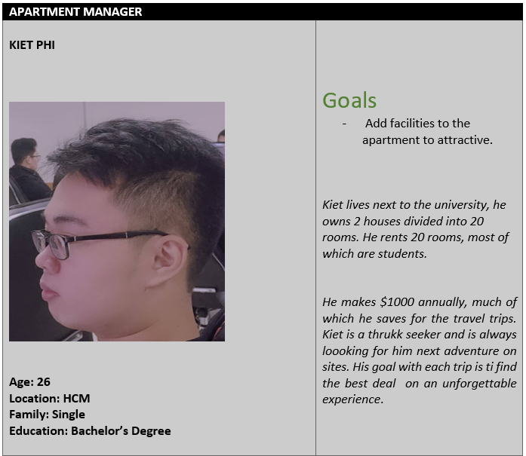

* Context for use (one paragraph or so)  
  We decided to build an app for people who struggle to find the trip that doesn’t fit them, financial problems or willing to try something new according to the 3 personas(Hoang, Andy, Quoc)
* Information Architecture
* The three most important scenarios to the persona's success written as context scenarios or as storyboards from EXERCISE WEEK 08 (after any editing tweaks). Call out any changes from EXERCISE WEEK 08 and why.
  1. Hoang’s looking for a family trip with a budget $500 -800, He search on the app, and start look for flight ticket, hotel. However, almost ticket or hotel price is so higher than the money he has. So Hoang add this on the wish list. He’s waiting for the sale period and he can buy this for good price.
  2. Andy is looking for a trip after he sick. He search the app and start create the account. He look for the flight and hotel, the app has a lot of choice for airlines and hotels, there’s a wide range of prices. He can pay online and without any extra fees.
  3. Quoc broke his camera, so he’s looking for the shop where sell the lenes. He open the app and start search. However, Quoc meet the shop have a bad service, so he search again, and he can find the shop with good service and profession. But now, Quoc do not have enough money, so he can know he save how much enough money and then, he can buy the camera he wants.
* Flow diagram for each of the three scenarios that allows users complete the tasks proposed in your contextual scenarios after any editing tweaks (from EXERCISE WEEK 08). Call out any changes to flow and why.

Hoang:

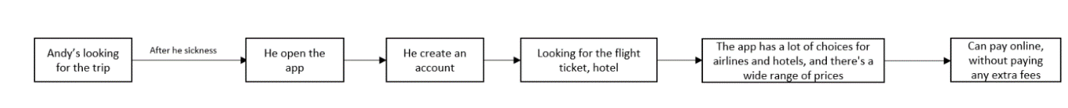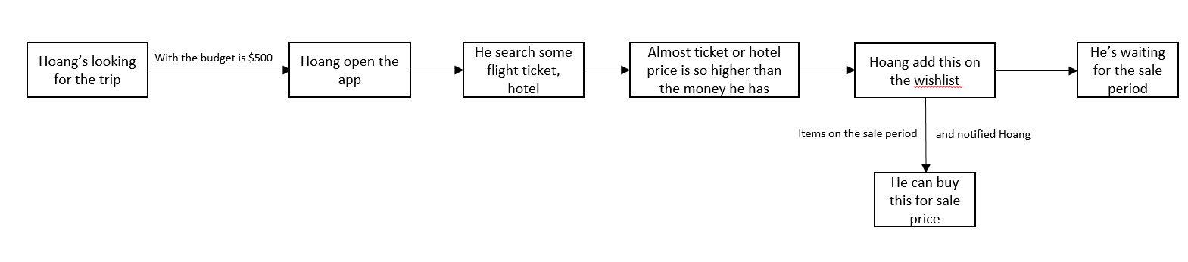Andy:

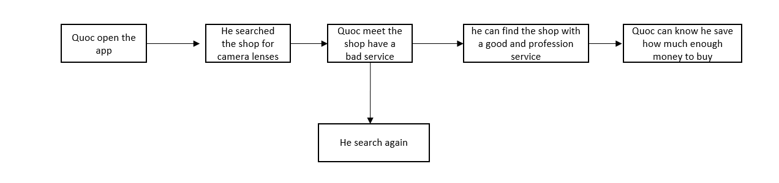Quoc:

1. Prototype uploaded to AxShare. Turn in the URL in the Comments section for the assignment. 3) Early sketches or mockups in any fidelity to show your ideation process. Document key features and concepts you are exploring.

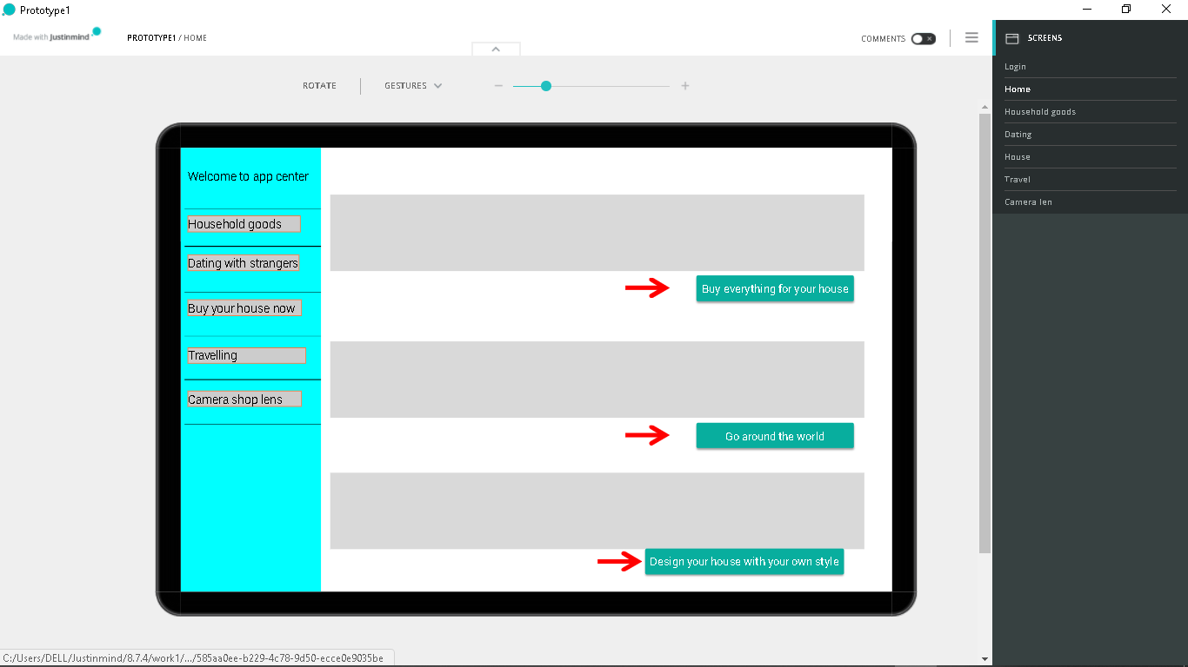

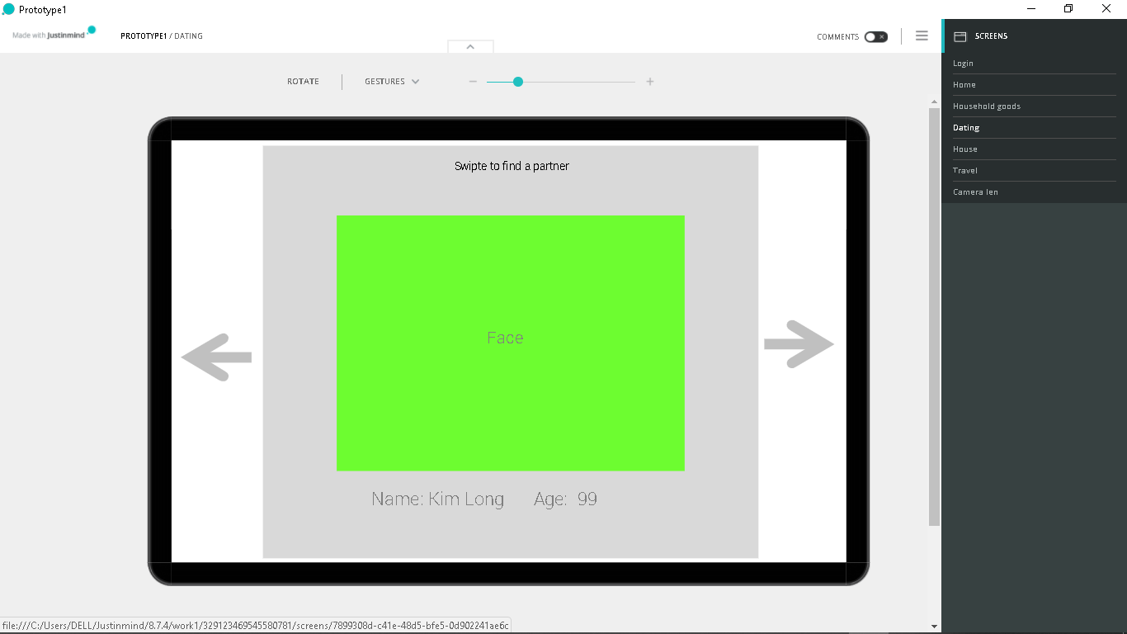

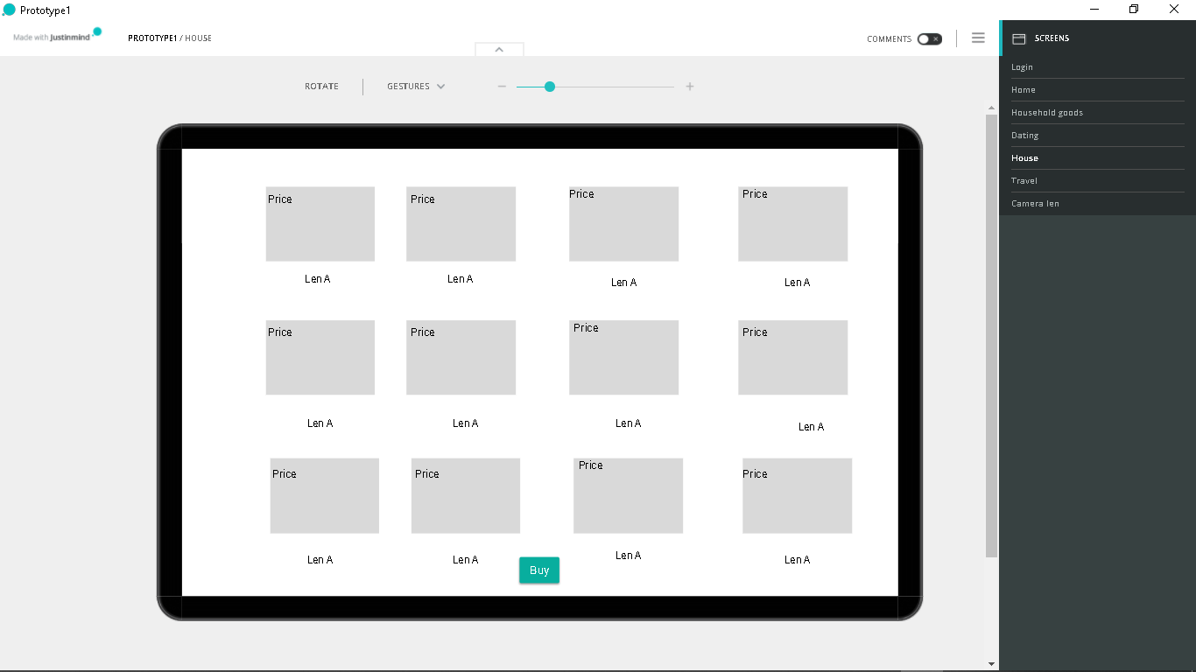

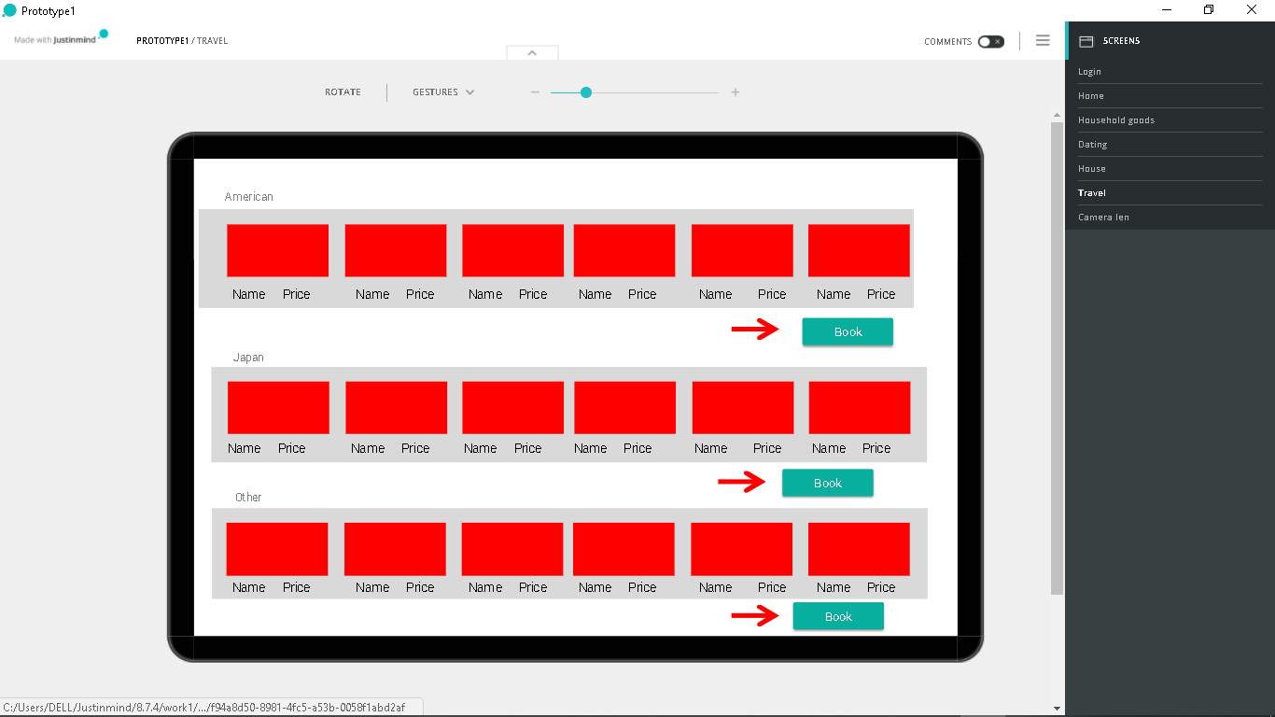

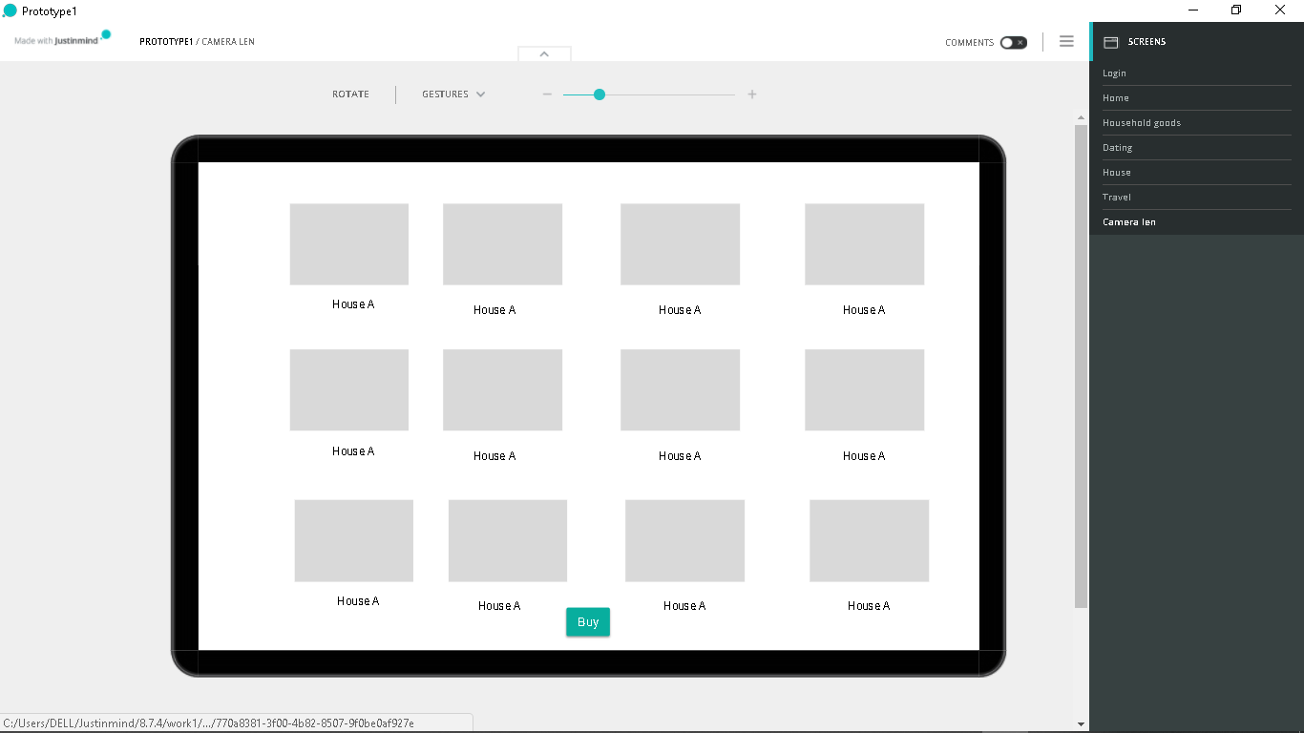

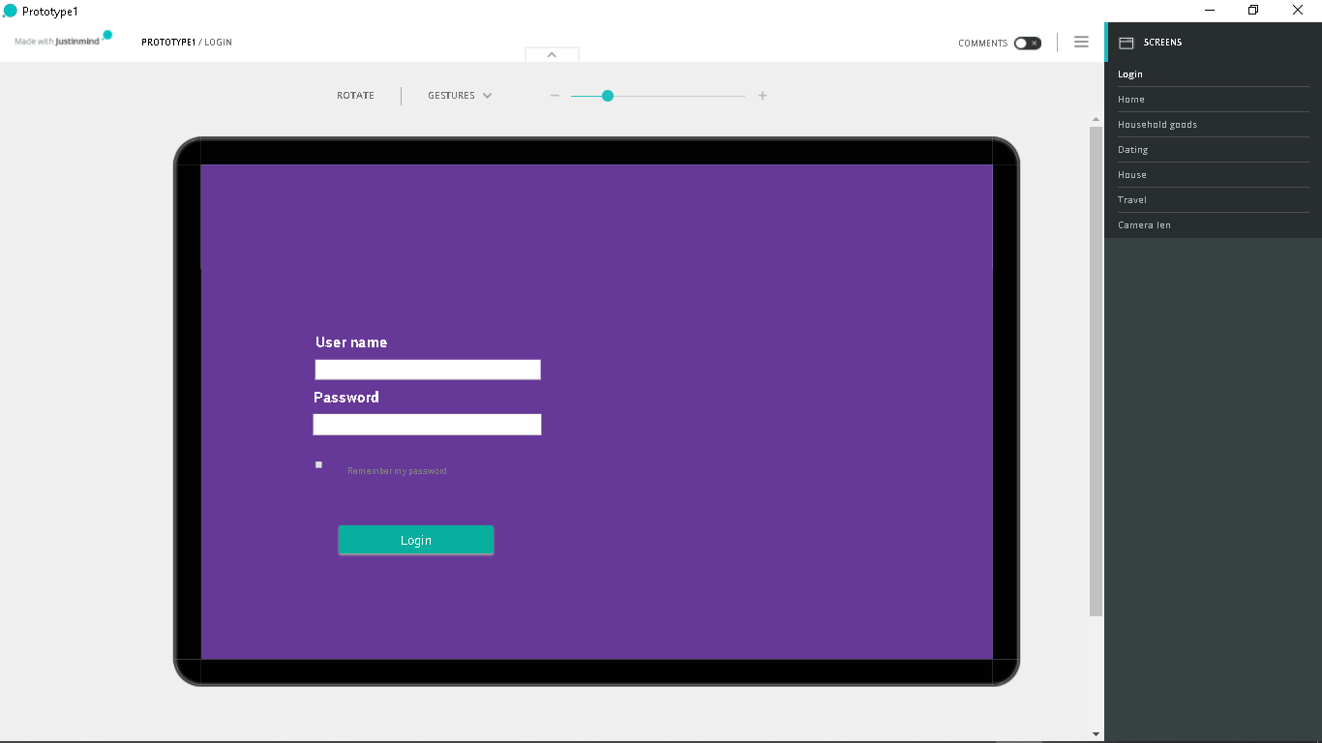

1. Document 5 key design patterns used in your final design:

* One for navigation
* One for an animation/transition
* One for layout and placement
* One for interactive controls (buttons, sliders, clickable areas, etc.)
* One for something that you think is interesting or innovative

For each design pattern identify:

* What it is & How it works
* When to use it
* When does it break down (not work)
* Why it works - what is the psychology behind it
* Three digital examples from the wild (provide screenshots or links)

  Navigation : It uses for navigating to the new screen

When to use it : If you want to go to another screen, you can swipte left to right to open the drawer. Then, you can navigate to whatever screen you like by pressing the button

When does it break ? : It always works if you are inside this app.

Why it works ? : People have different interests, so they need to switch to thing they like. Navigation helps them to do it

Examples 1 :

1. Go from home to household goods:
2. Click on the household goods button
3. 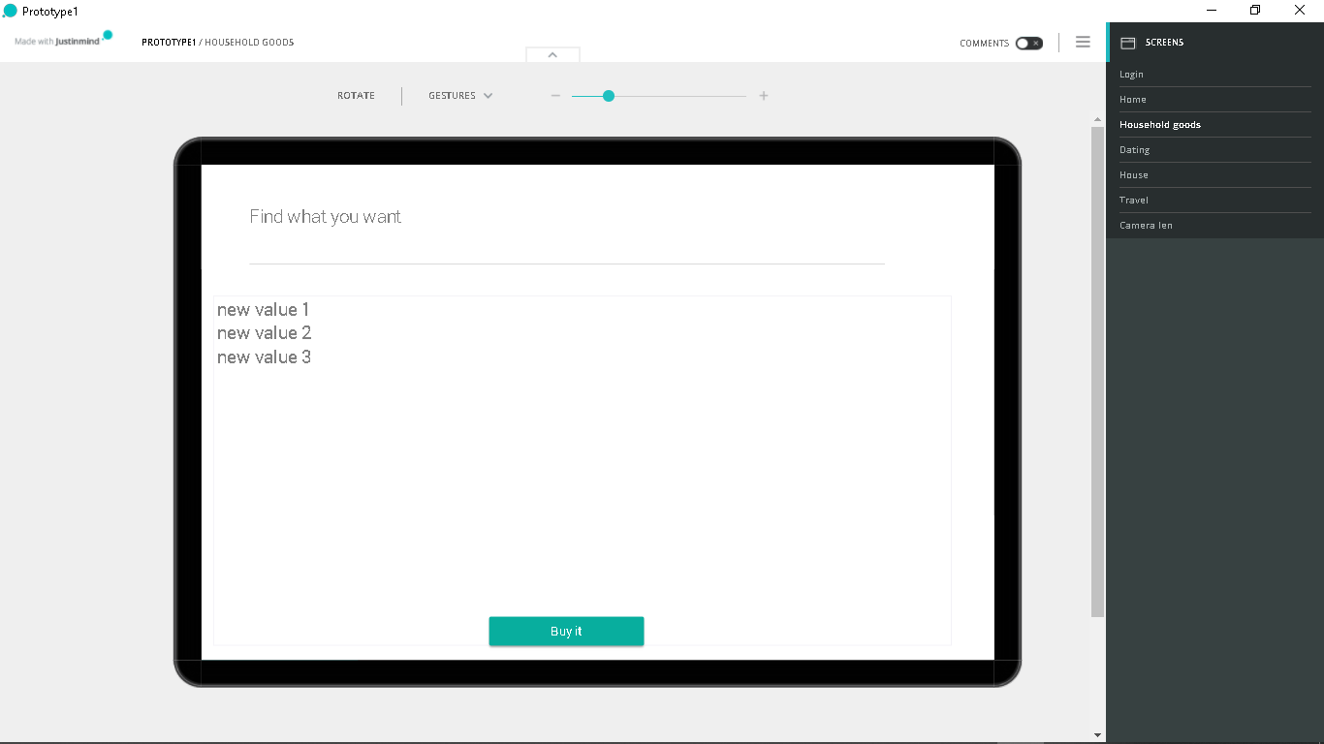Navigate to that screen

:

Examples 2 :

1. Go from home to dating screen:
2. Click on the dating with strangers
3. Navigate to that screen

Examples 3 :

1. Go from home to dating screen:
2. Click on the travelling buton
3. Navigate to that screen



Animation:

1. When click on the button, the opacity of this button will change fast ( 0.3s) from 0 to 1
2. When click on the login button, two username and password form will be animated to the to bottom by reducing their translation X
3. When the navigation shows up, they will have the beautiful effection like scale down, scale up or earsing.

We use animations to beauty the application and make it more friendly to the users

Layout and placement:

The layout will have the flexible dimensions so it is easy to use on diffrence devices. It not only good to test our UI on various devices, but also let the users feel comfortable when using our app.

Placement will have the comfortable position for the users can tap on it easily. It also have the good color for some placement which is special like buy button

Interactive controls:

We have a lot of interaction on the app such as button,swipe gesture, arrow button, drawer, …

Button: When the users when to confirm some actions or want to buy something

Swipe gesturer: When the users want to open the drawer, find a partner in Dating

Clickable areas: The usercan longPress on item or button to show up its description

Why it works? The users need to interact with our app, they need to press or do something impact to the UI, so the app can show the information correctly depending on what they want.

The thing I want to proude of in this UI is the layout so beautify and have the perfect harmony to another components. Your app can have many services to do but if your UI is not good, the users will still don’t like it.

**Additional Notes**

These deliverables are a low-fidelity interactive prototypes (keep it black and white). Users in a usability study should be able to follow the scenarios and navigate from one page to another. Do not work on application screens for other potential features that are not part of your scenarios. Use actual content. If you don't have any, make some up. Include both verbose and short content to push the boundaries of your design.

Rubric

| Rubric | | |
| --- | --- | --- |
| **Criteria** | **Ratings** | **Pts** |
| This criterion is linked to a Persona, IA, Scenarios, and Flow diagram, and early mockups | |  |  | | --- | --- | | **10.0 pts**  **Full Marks** | **0.0 pts**  **No Marks** | | 10.0 pts |
| This criterion is linked to a Lo-fidelity clickable prototype | |  |  | | --- | --- | | **10.0 pts**  **Full Marks** | **0.0 pts**  **No Marks** | | 10.0 pts |
| This criterion is linked to a Design patterns with breakdown. (2 pts each) | |  |  | | --- | --- | | **10.0 pts**  **Full Marks** | **0.0 pts**  **No Marks** | | 10.0 pts |
| Total Points: 30.0 | | |